Need Service for Following modules in Helpkids App:

1) Apply Now

2) News Feed

3) Gallery

4) Video

5) Donate Now

6) Join With Us

1. ApplyNow:

Method: Post

Input:

{

“StudentName” : “ ”,

“EmailAddress”: “ ”,

“ContactNumber”: “ “,

“School/CollegeName”: “ “,

“Course”,

“City”

}

Attachments:

1) profile photo

2) Mark sheet

3)Fees Structure

The image we upload to server should be base 64 format.

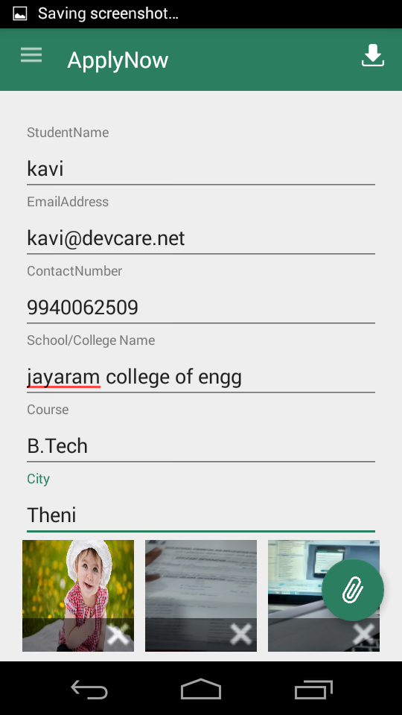 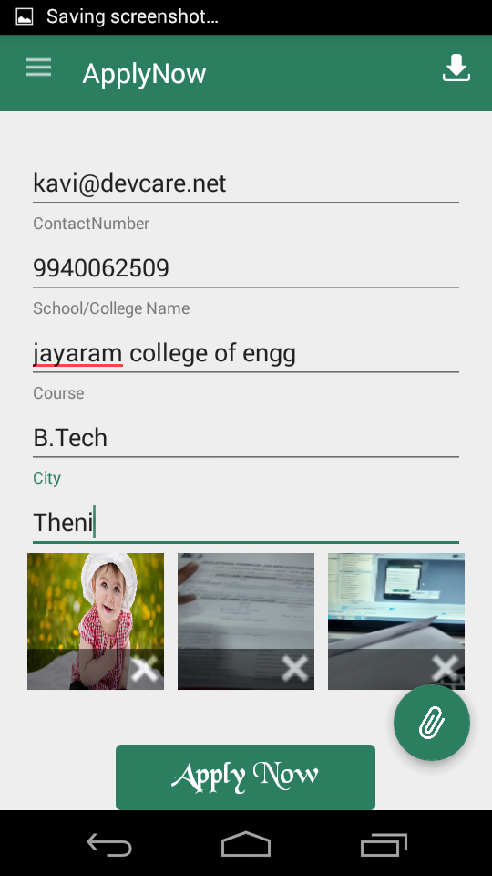

2) News Feed

3) Gallery:

4) Video

5) Donate Now

Method: Post

Input:

{

“Sponser Name”,

“EmailAddress”,

“Contact Number”,

“Amount”

Categories:

{

“School Students”,

“Non-professional Students”,

”Professional Students”

}

}

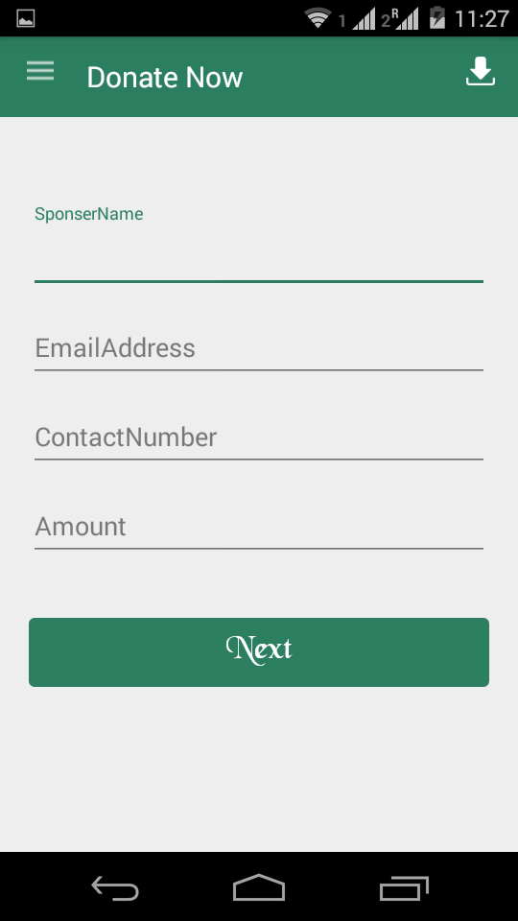

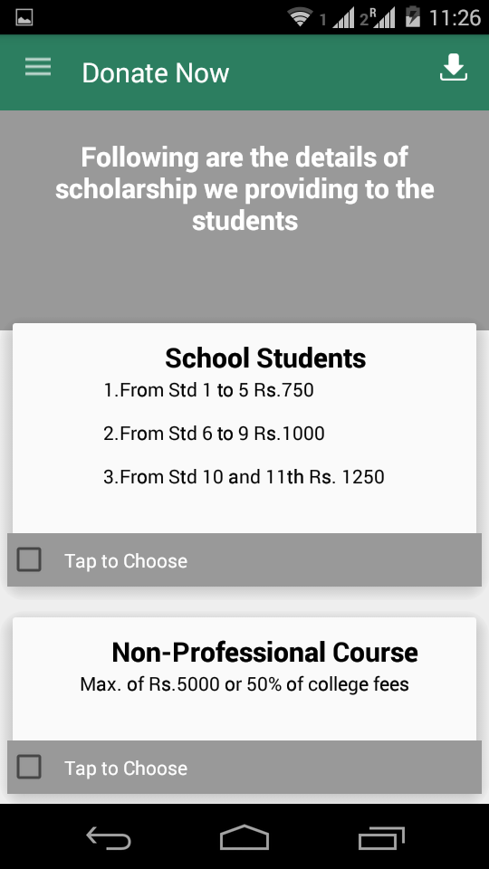 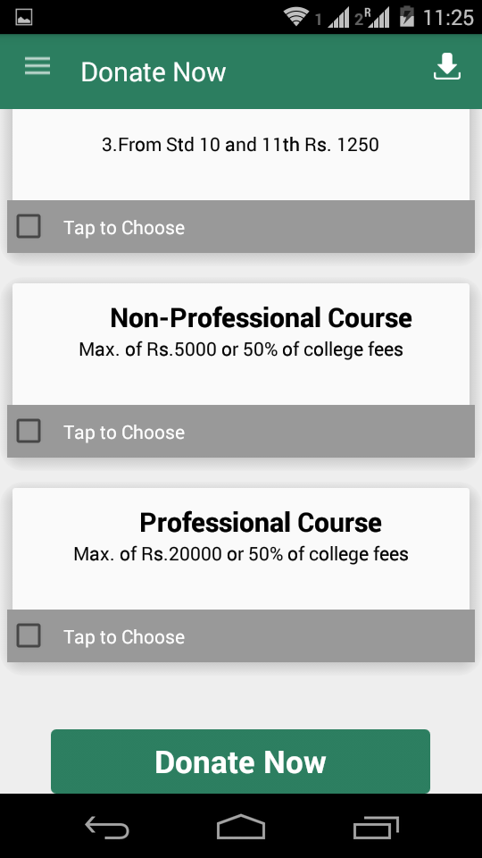

6) Join With Us:

Method: Post

Input:

{

“Volunteer Name”,

“Email Address”,

“Country Code”

“Contact Number”,

“Gender”,

“Date of birth”,

“Address”,

“Country”,

“State”,

“City”,

“Pin Code”,

}

